EOS M 290 Extended Reality Basic Training app now available in stores

- The “EOS M 290 Basic Training” app enables existing and new employees to train on systems faster than ever, at speed, from anywhere, and even before delivery
- The extended reality (xR) app, is now available in the Additive Minds Academy store, for Apple and Android devices

Krailling/Germany, June 15, 2022 – The Additive Minds Academy, the EOS education provider for the additive manufacturing (AM) industry, is accelerating learning curves for customers with its first Extended Reality (xR) app, for the EOS M 290 system. The EOS M 290 Basic Training app enables existing and new employees to train on systems faster than ever, at speed, from anywhere, and even before delivery, creating cost savings for companies. An application specialist will learn how to operate the EOS systems and software as well as be equipped with the skills to advise customers and stakeholders, ensuring the success of every aspect of the process chain.

The First AM machine-based training app
Extended reality (xR) technologies continue to transform education and contribute to the best possible learning outcomes when used correctly. The EOS M 290 Basic Training app, it is possible to place the award-winning system anywhere and give trainees an immersive augmented reality (AR) experience. This will allow them to be familiarized with the main system components and interact with a full-size model of the EOS M 290.

Faster learning curve
The EOS M 290 Basic Learning app together with the Blended Learning Paths has drastically reduced on-boarding times for employees to familiarize themselves with the system, from several months to four to six weeks. It replaces on-site training for the onboarding of new employees and the training and development of existing employees on new systems. This first distance learning course in the AM world for the EOS M 290 system is now available in the Additive Minds Academy Store, for Apple and Android as of today.

Volker Kunze, Technology Scout & Expansion Manager states: “Industrial 3D printing offers companies immense potential in the development of new applications. Especially for newcomers, it is important to build up know-how quickly. EOS is committed to offering the best learning experience – with state-of-the-art learning methods that are engaging and fun to use, smart and available anytime, anywhere.” He goes on to say: “The app can reduce operator training to just two or three days, at the same time decoupling training from machine availability on-site. As such, a company can use the waiting time effectively by starting training before the new system arrives.”

Choong Yue Hao, Lead Development Engineer Additive Manufacturing at ARTC shares his experiences: “The EOS M 290 app, has been jointly developed with EOS Singapore to support the ‘Additive Manufacturing Master Class’ that our trainers are providing as a team. It allows us to engage better with a larger group of trainees on the training content without additionally having to be mindful about their personal safety. The augmented reality functions enable trainees to have realistic interactions with a life-like 3D printer model. Every trainee is thus able to fully focus on the actual learning content of EOS M 290 operation in a comfortable classroom environment at his or her own pace.”

About the Additive Minds Academy
The Additive Minds Academy is the first all-embracing training and education provider for polymer- and metal-based industrial 3D Printing in the additive manufacturing (AM) industry. With different learning paths tailored to different demands, companies can optimize their onboarding processes and accelerate learning curves for the introduction of AM innovation. The training portfolio consists of digital learning paths for all levels of expertise EOS experts re- and upskill for a wide range of roles, such as machine operator, application specialist and data preparation specialist. https://store.eos.info

About EOS
EOS provides responsible manufacturing solutions via industrial 3D printing technology to manufacturers around the world. Connecting high quality production efficiency with its pioneering innovation and sustainable practices, the independent company formed in 1989 will shape the future of manufacturing. Powered by its platform-driven digital value network of machines and a holistic portfolio of services, materials and processes, EOS is deeply committed to fulfilling its customers’ needs and acting responsibly for our planet. www.eos.info

Images https://www.eos.info/en/presscenter/pressreleases-overview

Volker Kunze,Technology Scout & Expansion Manager
(Source: EOS)
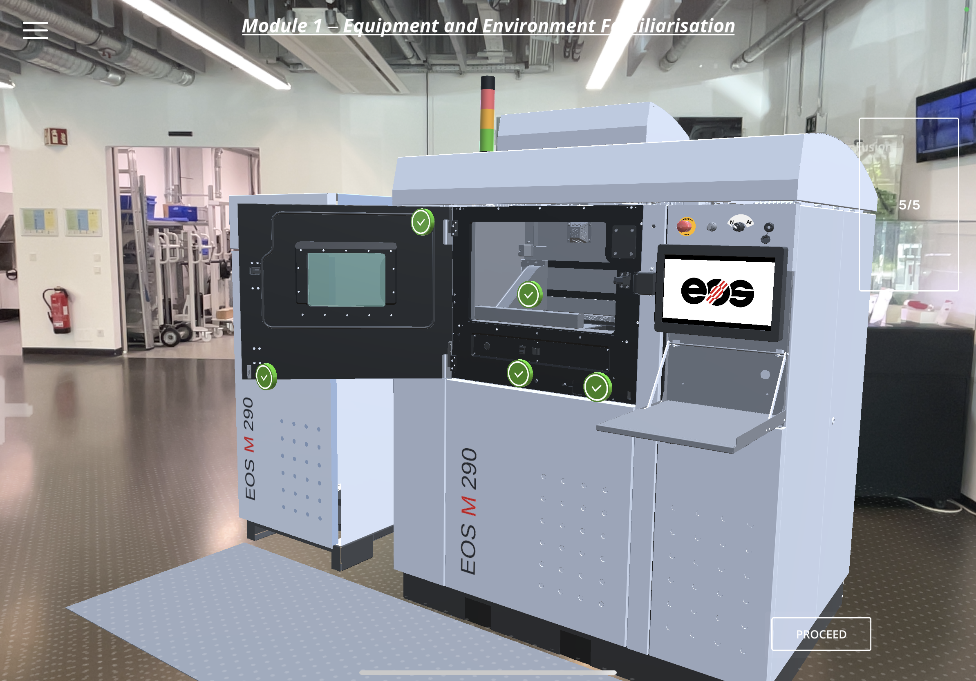 | The First AM machine base training app for the EOS M 290 (Source: EOS)
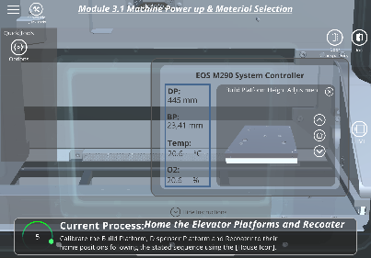 | Virtual reality conveys machine knowledge in a safe environment and in a quality-assured form. (Source: EOS)

Contact

EOS GmbH Electro Optical Systems
Claudia Jordan
Press Officer
+49 89 89336-2134
claudia.jordan@eos.info

