Award-winning consulting: EOS Additive Minds receives TOP CONSULTANT seal 2022

- Competition determines best consultants for small and medium-sized businesses
- Former German Federal President Christian Wulff congratulates
- EOS received the award for the fourth time

Krailling/Germany, June 27, 2022 – EOS, a leading supplier for responsible manufacturing solutions via industrial 3D printing technology, has been awarded the TOP CONSULTANT seal 2022 to their Additive Minds Consultancy team at the German SME Summit in Frankfurt on June 24, for the 4th time. During the German SME Summit, former German Federal President Christian Wulff, who accompanies the competition as a mentor, congratulated EOS on its success. EOS previously received the award in 2017, 2019, and 2020.

For 13 years, the TOP CONSULTANT quality seal has represented the highest level of consulting competence in medium-sized businesses – based on a scientifically founded customer survey. It measures professionalism, constant service delivery and customer satisfaction.

From pure technology consultant to strategic business consultant
In 2013, EOS founded its own, then pure technology consultancy under the name 'Additive Minds'. It now consists of around 100 experts worldwide - including engineers, mechanical engineers, and business economists, offering extended strategic business consulting.

EOS consultants support clients with customized, industry-specific solutions along the entire value chain. This starts with the strategic question of whether the introduction of industrial 3D printing pays off for a company, through the holistic optimization of the additively manufactured component, to customized trainings and certified learning paths via the Additive Minds Academy.

Additive Minds not only supports newcomers with the successful introduction of 3D printing technology, but also experienced customers in the scaling and optimization of digital factories based on additive manufacturing.

Thomas Weitlaner, Director Key Account Management & Additive Minds at EOS comments: "We are very pleased to have won the award again. More than 500 successfully implemented projects worldwide show us that our competent and result-oriented consulting offers exactly what customers need: Consulting from practice, for practice, specialist know-how as well as speed and flexibility in consulting."

And he adds: "Our consulting clients include not only innovative medium-sized companies, but also start-ups and globally active large corporations. Together with these customers, we develop innovative product solutions based on additive manufacturing. This enables them to achieve novel and more efficient product designs, drive cost savings in the process chain or a faster time-to-market. The last few years have also shown the great advantages that 3D printing plays in stabilizing supply chains and manufacturing spare parts on demand."

Prof. Dr. Dietmar Fink, Professor of Management Consulting at Bonn-Rhein-Sieg University of Applied Sciences, heads the Scientific Society for Management and Consulting together with Bianka Knoblach. They decide who is honored with the TOP CONSULTANT seal. "We award those consultants that understand particularly well how to address the special needs of medium-sized companies," says Prof. Dr. Dietmar Fink.

On behalf of compamedia, the Scientific Society for Management and Consulting (WGMB) from Bonn examined the participating consultancies. The competition is based on a survey of medium-sized companies that had previously worked with them. The reference customers named by EOS provided information on, for example, how professional EOS appeared, how satisfied they were with the consulting services, and also whether they would recommend EOS to others.

About EOS
EOS provides responsible manufacturing solutions via industrial 3D printing technology to manufacturers around the world. Connecting high quality production efficiency with its pioneering innovation and sustainable practices, the independent company formed in 1989 will shape the future of manufacturing.

Powered by its platform-driven digital value network of machines and a holistic portfolio of services, materials and processes, EOS is deeply committed to fulfilling its customers’ needs and acting responsibly for our planet. www.eos.info

Images https://www.eos.info/en/presscenter/pressreleases-overview

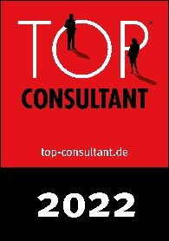 | Top Consultant seal 2022 (Source: Compamedia)
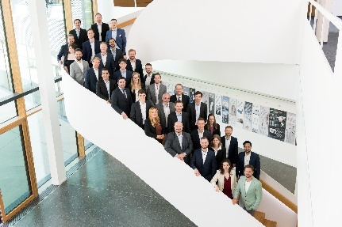 | Additive Minds team in Germany (Source: EOS)
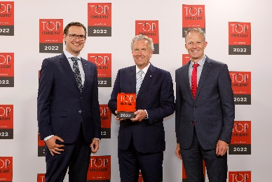 | Award ceremony June 27, 2022: (f.l.t.r.). Davy Orye/EOS, TOP CONSULTANT mentor Christian Wulff/former Federal President, Thomas Weitlaner/EOS (Source: KD Busch / compamedia)

Contacts

EOS GmbH Electro Optical Systems
Claudia Jordan
Press Officer
+49 89 89336- 2134
Claudia.jordan@eos.info

